Offton and Willisham Parish Council

Clerk to the Council: Miss T Davis
69 Gardeners Rd
Debenham
STOWMARKET
IP14 6RX
Tel: 07425 672631
Clerk@offtonandwillisham.org.uk

3rd April 2024

I hereby give notice that a EGM of Offton & Willisham Parish Council will be held at the Offton and Willisham Village Hall on Monday 8th April 2024 commencing at 7.30pm. The Press and the Public are invited to attend, Councillors are summoned to attend.
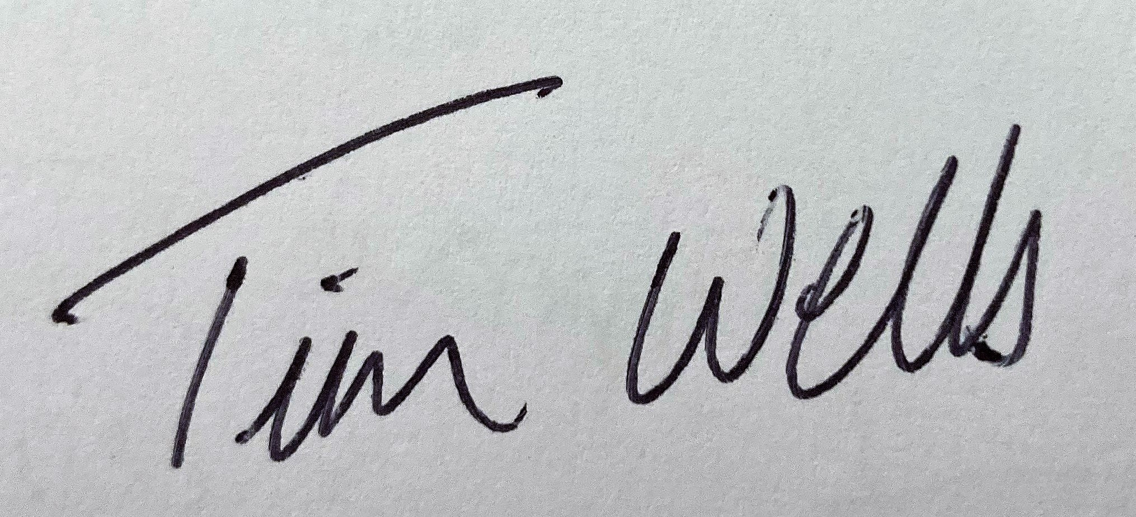 Chair of Offton and Willisham Parish Council

The Parish Council, members of the public and the press may record, film, photograph or broadcast this meeting when the public and the press are not lawfully excluded. Any member of the public who attends a meeting and wishes to record, film, and photograph or broadcast the meeting should advise the Parish Clerk.
Public questions during a remote meeting: Questions can be forwarded to the Clerk prior to the meeting via email (as above) or given in person during item 4 - Public Participation. Members of the public may not take part in the Parish Council meeting itself, unless with the permission of the Chairman to do so.

AGENDA

- Meeting administration
- Chair to open the meeting and welcome everyone
- To consider and approve apologies for absence
- To receive Declarations of interest on agenda items
- To Approve the draft minutes of the Parish Council meeting on 4th March 2024 and for the Chairman to sign as a true record
- Matters arising from the minutes:-
- Public Participation Session (To hear reports from the County Councillor, District Councillor and Comments from the Public)
- Planning & Governance Consultations
i. Pre-Submission - Aldham Neighbourhood Plan views on draft focused review (13th May)
ii. Pre-Submission - Elmsett Neighbourhood Plan views on draft focused review (13th May)
iii. MSDC DC/24/01057 - Application for Reserved matters for 11 dwellings, commercial (office) space, A1/A3 farm shop/cafe, new vehicular access, new footpath, play area, parking, landscaping and attenuation (extended deadline 9th April)
iv. NSIP National Grid Norwich to TIlbury Proposal - Mid Suffolk Request for feedback
- Next meeting scheduled for Monday 20th May 2024 at 6pm will be the Annual Parish Council meeting followed by the Annual Parish Meeting

